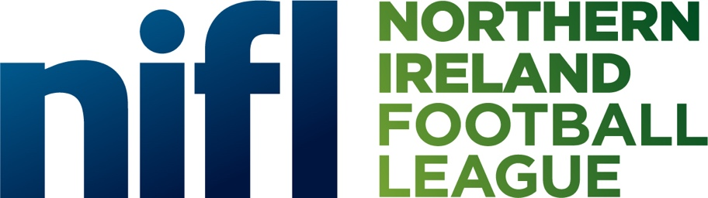

JOB DESCRIPTION
Sales and Marketing Executive
May 2023
INTRODUCTION
Thank you for your interest in joining the team at the Northern Ireland Football League (NIFL).
Within Irish League football we pride ourselves as the second oldest football league in the world we have a long and proud history but right now we’re not just embracing the past but looking forward. We are building a stronger identity for our leagues and creating a better experience for our fans.
The NIFL is an organisation that puts our clubs first and is embodied by the membership of our 46 clubs that compete as the top three men’s leagues and top women’s league in Northern Ireland football structure.
The flagship Sports Direct Premiership has seen an unprecedented rise in popularity in since the inception of the NIFL, with over 380,000 spectators attending games each season and a broadcast audience of over 2.8 million watching games on TV through BBC Sport NI and Sky Sports.
This rise in popularity has transcended the organisation with a rise in overall audience, sponsorship opportunities and on the pitch progress with our clubs as an influx of exciting new talent has risen the bar and substantially improved member clubs’ performances in European Club Competitions.
It is a hugely exciting time to be joining the Northern Ireland Football League, and I wish you every success with your application.

WORKING AT THE NI FOOTBALL LEAGUE
Working within the Northern Ireland Football League is a unique experience.
The nature of football and sport means that we operate at a fast-paced and constantly changing environment created around the traditional Saturday afternoon matchday.
Operating from the National Football Stadium at Windsor Park in Belfast, the office provides one of the optimum workplace settings within all of Northern Ireland with a stunning panoramic view of the famous pitch which has been graced by countless world class players from across Europe.
The company holds Limited status, and is governed by a Board of Directors, the majority of whom are appointed from within the membership of the clubs and work closely with the Chief Executive to oversee and manage the long-term strategies of the business.
If you love football and share our passion for Irish League football realise its ambitions, we’d love to hear from you!

JOB DESCRIPTION
The new Sales and Marketing Executive role will play a key role in NI Football League (NIFL) as it looks to continue its strong growth in men’s and women’s elite football in Northern Ireland. This role to support our Chief Commercial Officer in sourcing, activating and reporting on sponsor activity, plus help in delivering seasonal campaigns across outdoor, PR and social.
KEY RESPONSIBILITIES
  - Attend sponsorship activation meetings with marketing & communication representatives from partners.
  - Assist the creative planning and delivery of joint obligations in line with each of the respective contracts.
  - Assist the creative planning and delivery of seasonal campaigns to support the leagues.
  - Support the management of Partnerships in line with their business objectives and partnership KPI’s.
  - Ensuring all contractual rights are delivered in a timely manner and to the highest standard.
  - Assisting with the planning and implementation of partnership marketing campaigns, working with the member club’s marketing departments and taking into consideration marketing strategy and business objectives.
  - Establishing and maintaining strong internal relationships to aid the delivery of sponsorship rights and the addition of new potential partners.
  - Help to track the effectiveness of sponsorship campaigns and provide analysis on key success measures demonstrating ROI.
  - Responsible for sponsorship materials and meetings.
  - Day to day administration as required by partners.
  - Track all assets and ensure rights are being delivered across the men’s and women’s team home matches.

PERSONAL SPECIFICATION
Essential qualifications
- A third level qualification in marketing or digital marketing is essential or as an alternative Two years relevant experience will be accepted.
Essential experience
- A minimum of Two years recent experience in similar role
Essential skills, knowledge and abilities
- Excellent written and verbal communication skills.
- Excellent planning, organisational and prioritisation skills including, editorial skills for content and imagery, search engine optimisation, functionality enhancements and increasing the traffic and engagement of visitors.
- Demonstrate ability to manage multiple social media platforms and increase the number of people engaging with them.
- Interest and passion for football and sport.

Desirable Skills / Knowledge

- Knowledge or Experience of NI Football League
- Experience in the Sport Industry

The Northern Ireland Football League promotes inclusion and diversity and welcomes applications from everyone.

This is a hugely exciting career opportunity for a sales professional in a changing, dynamic and renowned sports organisation. Applicants must have a flexible approach to work and be able to work evenings, weekends and match days as required.

TERMS AND CONDITIONS
The role offers a competitive salary on a permanent contract, which will be negotiable dependent on relevant experience.
This role is required 40 hours per week, which will include some weekend work, primarily on Saturdays.
Primary Location: National Football Stadium at Windsor Park, Belfast.
Applicant must also have access to their own transport.
Northern Ireland Football League Ltd are an Equal Opportunities Employer.

DISCLOSURES
The NI Football League will seek confirmation that the successful applicant has the right to work in the UK. Any offer of employment will be made subject to verification of the right to work in the UK, receipt of satisfactory references and a satisfactory Access NI Disclosure.
Having a criminal record will not necessarily debar you from working for the NI Football League. This will depend on the nature of the position, together with the circumstances and background to your offences or other information contained on a disclosure certificate provided directly to us by the Police Service of Northern Ireland.
APPLICATIONS
All applicants should submit a cover letter and curriculum vitae (CV) to recruitment@nifootballleague.com before 5pm on 24th May 2023.

